Cevian

Definition
# Source: AI Source: Provided by: [Data Path: Persons Table -> ID Column: 1, Name_En Column: Motasem Essam] -> From: [ChatGPT] on [7/25/2026]
A Cevian is a line segment that joins a vertex of a triangle to a point on the opposite side, or to a point on the line containing that opposite side.
For triangle $△ABC$, if $D$lies on line $BC$, then $\overset{‾}{AD}$is a cevian from vertex $A$.
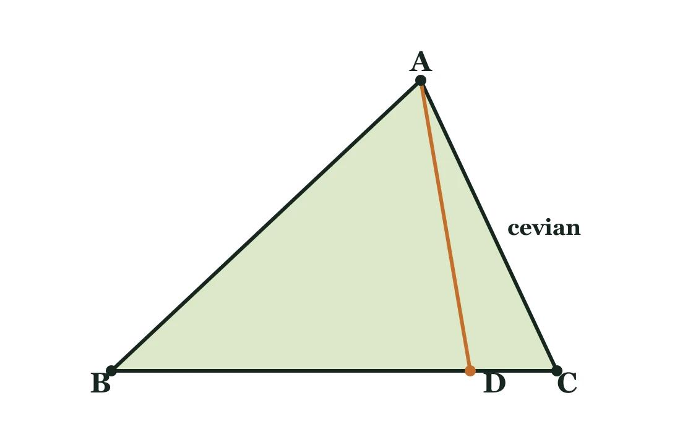

Simple Definition
# Source: AI Source: Provided by: [Data Path: Persons Table -> ID Column: 1, Name_En Column: Motasem Essam] -> From: [ChatGPT] on [7/25/2026]
A cevian is a segment drawn from a triangle's vertex to the opposite side or its extension.
- Vertex: $A$
- Opposite side: $BC$
- Point on the opposite side: $D$
- Cevian: $\overset{‾}{AD}$
A cevian does not have to be perpendicular to the opposite side or bisect it.

Main Types of Cevians
# Source: AI Source: Provided by: [Data Path: Persons Table -> ID Column: 1, Name_En Column: Motasem Essam] -> From: [ChatGPT] on [7/25/2026]
These are common named types of cevians, classified by the special property they satisfy.

1. Median
# Source: AI Source: Provided by: [Data Path: Persons Table -> ID Column: 1, Name_En Column: Motasem Essam] -> From: [ChatGPT] on [7/25/2026]
A cevian that meets the opposite side at its midpoint.
Condition: $BD=DC$
Example: If $BC=10$, then $BD=DC=5$.
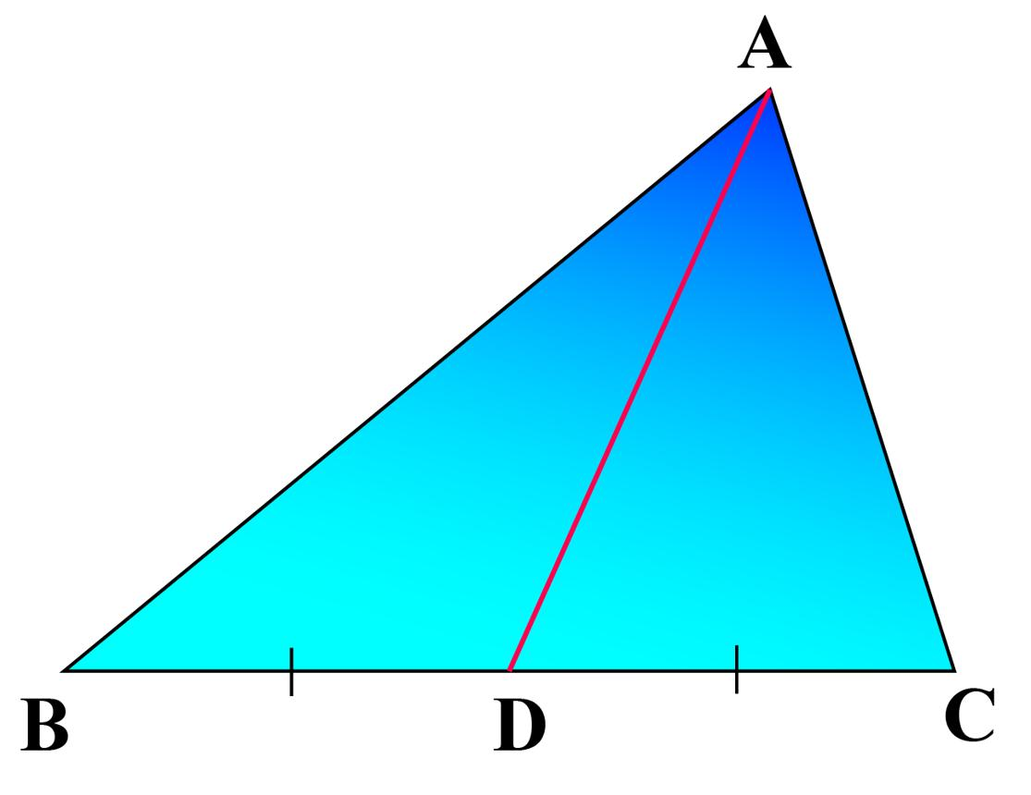

2. Angle Bisector
# Source: AI Source: Provided by: [Data Path: Persons Table -> ID Column: 1, Name_En Column: Motasem Essam] -> From: [ChatGPT] on [7/25/2026]
A cevian that divides the vertex angle into two equal angles.
Condition: $∠BAD=∠DAC$
Example: If $∠A={80}^{∘}$, each smaller angle is ${40}^{∘}$.
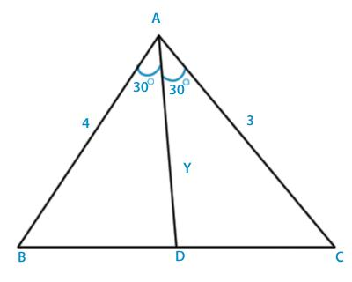

3. Altitude
# Source: AI Source: Provided by: [Data Path: Persons Table -> ID Column: 1, Name_En Column: Motasem Essam] -> From: [ChatGPT] on [7/25/2026]
A cevian whose supporting line is perpendicular to the opposite side or its extension.
Condition: $AD⊥BC$
Example: If $AD$is an altitude, then $∠ADB={90}^{∘}$when $D$lies on segment $BC$.
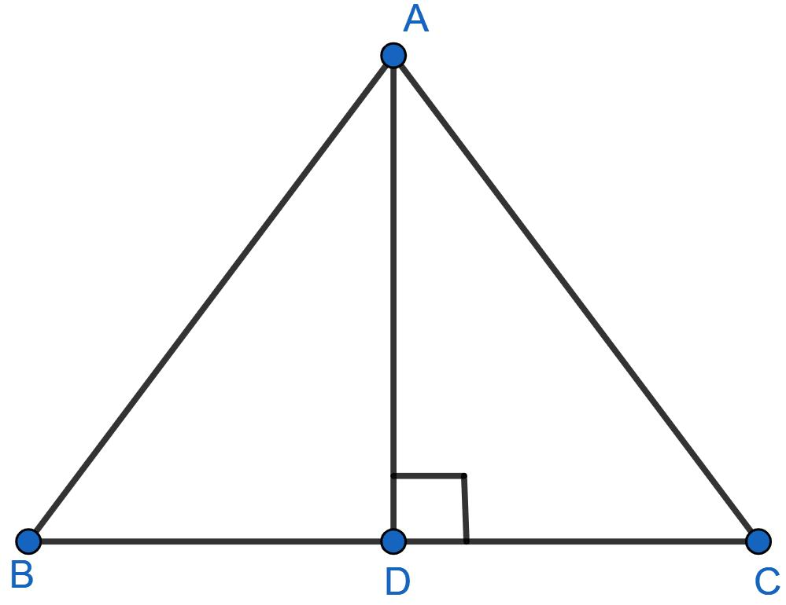

4. General Cevian
# Source: AI Source: Provided by: [Data Path: Persons Table -> ID Column: 1, Name_En Column: Motasem Essam] -> From: [ChatGPT] on [7/25/2026]
A cevian that does not necessarily satisfy the special conditions of a median, angle bisector, or altitude.
Example: $BD=3$and $DC=7$, with no requirement that $AD$bisects the angle or is perpendicular to $BC$.
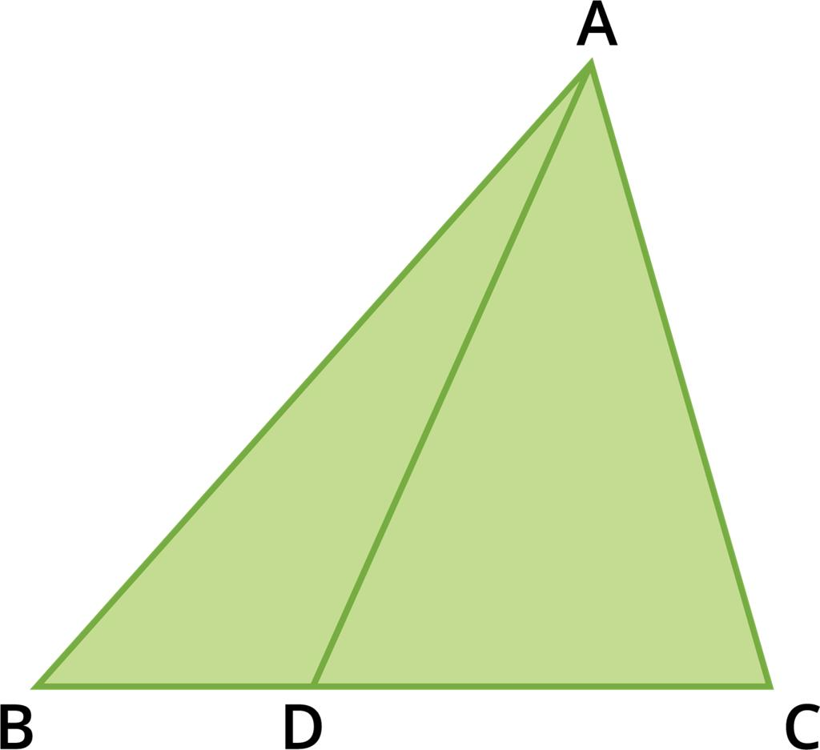

Important Properties and Theorems

A. Ceva's Theorem
# Source: AI Source: Provided by: [Data Path: Persons Table -> ID Column: 1, Name_En Column: Motasem Essam] -> From: [ChatGPT] on [7/25/2026]
Ceva's theorem determines when three cevians of a triangle meet at one common point.
In $△ABC$, let $D$lie on $BC$, $E$on $CA$, and $F$on $AB$. The cevians $AD$, $BE$, and $CF$are concurrent if and only if
$$\frac{BD}{DC}⋅\frac{CE}{EA}⋅\frac{AF}{FB}=1$$
for the standard internal-division configuration.
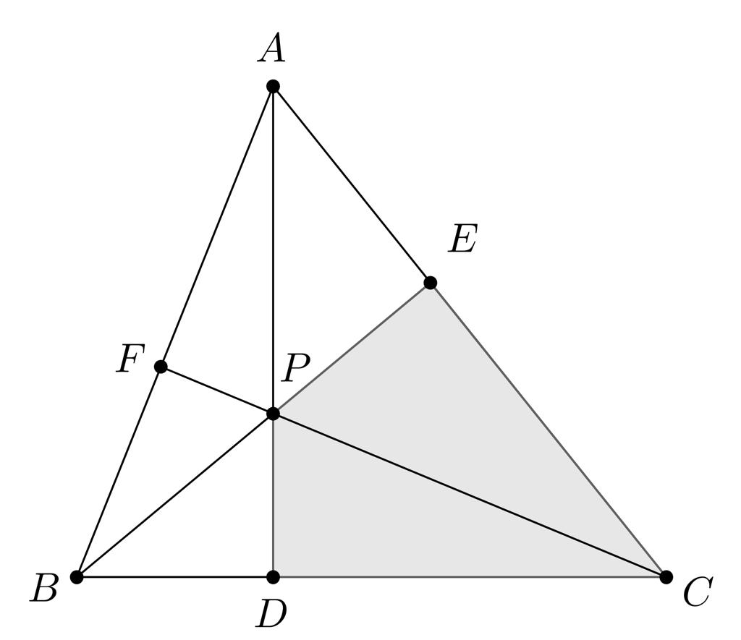
Example: If all three points $D,E,F$are midpoints of their respective sides, all three ratios equal $1$. Their product is $1$, so the three medians are concurrent.

B. Angle Bisector Theorem
# Source: AI Source: Provided by: [Data Path: Persons Table -> ID Column: 1, Name_En Column: Motasem Essam] -> From: [ChatGPT] on [7/25/2026]
If $AD$bisects $∠A$, then
$$\frac{BD}{DC}=\frac{AB}{AC}$$
Example: If $AB=6$, $AC=9$, and $BD=4$, then
$$\frac{4}{DC}=\frac{6}{9}$$
so $DC=6$.

C. Median Length Formula
# Source: AI Source: Provided by: [Data Path: Persons Table -> ID Column: 1, Name_En Column: Motasem Essam] -> From: [ChatGPT] on [7/25/2026]
For a triangle with side lengths $a=BC$, $b=CA$, and $c=AB$, the median from $A$has length
$$m_{a}=\frac{1}{2}\sqrt{2b^{2}+2c^{2}-a^{2}}$$
This formula applies specifically to a median, not to every cevian.

Cevian vs. Median vs. Altitude vs. Angle Bisector
# Source: AI Source: Provided by: [Data Path: Persons Table -> ID Column: 1, Name_En Column: Motasem Essam] -> From: [ChatGPT] on [7/25/2026]
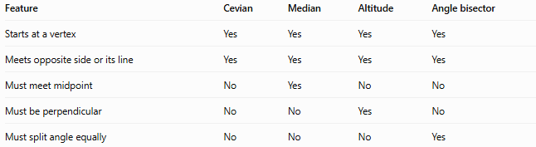
Feature | Cevian | Median | Altitude | Angle bisector
Starts at a vertex | Yes | Yes | Yes | Yes
Meets opposite side or its line | Yes | Yes | Yes | Yes
Must meet midpoint | No | Yes | No | No
Must be perpendicular | No | No | Yes | No
Must split angle equally | No | No | No | Yes
Key relationship: Every median, every altitude, and every internal angle bisector of a triangle is a cevian. However, not every cevian is one of these three special types.

Classification Summary
# Source: AI Source: Provided by: [Data Path: Persons Table -> ID Column: 1, Name_En Column: Motasem Essam] -> From: [ChatGPT] on [7/25/2026]
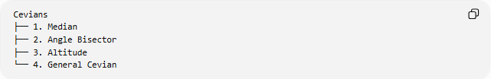
Cevians
├── 1. Median
├── 2. Angle Bisector
├── 3. Altitude
└── 4. General Cevian
This is a practical classification by familiar geometric properties, not an exhaustive universal taxonomy. Cevians can also be classified by whether they meet the opposite side internally or its extension.

Key Points
# Source: AI Source: Provided by: [Data Path: Persons Table -> ID Column: 1, Name_En Column: Motasem Essam] -> From: [ChatGPT] on [7/25/2026]
- A cevian connects a triangle vertex to the opposite side or its supporting line.
- The three principal special cevians are medians, altitudes, and angle bisectors.
- Cevians are central to Ceva's theorem, which tests concurrency.
- A cevian is not necessarily perpendicular to the opposite side or directed toward its midpoint.
- In an obtuse triangle, an altitude may meet the extension of the opposite side rather than the side segment itself.

Conclusion
# Source: AI Source: Provided by: [Data Path: Persons Table -> ID Column: 1, Name_En Column: Motasem Essam] -> From: [ChatGPT] on [7/25/2026]
A Cevian is a general triangle segment drawn from a vertex to the opposite side or its extension. Medians, altitudes, and angle bisectors are its most important special cases, each defined by an additional geometric condition.

